

**A PROJECT REPORT ON**

**“E-Learning Platform - LearniFy”**

**SUBMITTED BY**

Mr. Krushna Sopan Zarekar

Mr. Sanket Babasaheb Nagode

For

TYBBA(CA) Semester – VI, 2022-23

Savitribai Phule Pune University, Pune

**Under the guidance of**

**Prof. Nimbalkar Mam**



*Ahmednagar Jilha Maratha Vidya Prasarak Samaj’s*

**NEW ARTS, COMMERCE AND SCIENCE COLLEGE, AHMEDNAGAR**

**DEPARTMENT OF BBA(C.A)**

**CERTIFICATE**

This is to certify that

**Mr. Krushna Sopan Zarekar**

**Mr. Sanket Babasaheb Nagode**

has completed the Project on “E-LEARNING PLATFROM- LearniFy” for the partial fulfilment of TYBBA (C.A) Semester– VI MAY 2023 laid down by Savitribai Phule Pune University, Pune for the Academic year 2022-23.

His performance is ……………………

Project Guide H.O.D.

Prof. Nimbalkar Mam Prof Nimbalkar Mam

Internal Examiner External Examiner

**INDEX**

|  |  |  |  |
| --- | --- | --- | --- |
| Sr.  No. | Sub head | Title | Page No |
| 1 |  | INTRODUCTION | 5 |
|  | 1.1 | Introduction of the System | 6 |
|  | 1.2 | Need of System | 8 |
|  | 1.3 | Scope of the proposed system | 9 |
|  | 1.4 | Problem Definition | 10 |
| 2 |  | FACT-FINDING TECHNIQUES | 11 |
|  | 2.1 | Interview | 11 |
|  | 2.2 | Record Review | 11 |
|  | 2.3 | Observation | 11 |
| 3 |  | FEASIBILITY STUDY | 12 |
|  | 3.1 | Technical Feasibility | 12 |
|  | 3.2 | Operational Feasibility | 12 |
|  | 3.3 | Economic Feasibility | 12 |
| 4 |  | REQUIREMENT ANALYSIS | 14 |
|  | 4.1 | Software Specification | 14 |
|  | 4.2 | Hardware Specification | 14 |
| 5 |  | SYSTEM DIAGRAMS | 15 |
|  | 5.1 | ER Diagram, Class Diagram | 16 |
|  | 5.2 | Sequence Diagram | 17 |
|  | 5.3 | Use Case Diagram | 18 |
|  | 5.4 | Activity Diagram | 19 |
| 6 |  | INPUT OUTPUT SCREENS | 20 |
| 7 |  | DATABASE | 26 |
| 8 |  | FUTURE ENHANCEMENTS | 29 |
| 9 |  | CONCLUSION | 30 |
| 10 |  | LIMITATIONS OF THE SYSTEM | 31 |
| 11 |  | BIBLIOGRAPHY |  |

1. **INTRODUCTION**

LearniFy is a modern and innovative e-learning platform designed to provide learners with a seamless, engaging, and interactive learning experience. The platform is built to cater to the needs of learners across different age groups and learning styles, and is designed to be accessible from anywhere at any time.

LearniFy's user-friendly interface makes it easy for learners to navigate the platform and access the courses and resources they need. The platform features a diverse range of courses, including academic subjects, professional development, personal growth, and hobbies.

LearniFy's courses are designed by experts in their respective fields and are tailored to suit the needs of different learners. The platform also offers a variety of learning materials, such as videos, quizzes, assignments, and interactive simulations, to enhance the learning experience.

LearniFy's advanced learning management system provides learners with detailed feedback on their progress, and allows them to track their performance and set goals for themselves. Additionally, the platform features a social learning component, allowing learners to connect with peers and instructors, collaborate on projects, and share knowledge.

LearniFy's mission is to make learning more accessible, engaging, and effective for learners everywhere, and to help them achieve their personal and professional goals.

**1.2 NEED OF THE SYSTEM**

LearniFy is a comprehensive e-learning platform that fulfills the need for a modern, user-friendly, and accessible online learning system. The platform provides learners with a wide range of courses and resources tailored to their needs, making education more accessible and convenient for them. LearniFy's learning management system enables learners to track their progress and receive personalized feedback, allowing them to monitor their performance and identify areas where they need improvement. Additionally, LearniFy's social learning component facilitates collaboration and knowledge-sharing, creating a community of learners that enhances the overall learning experience. Overall, LearniFy meets the increasing demand for flexible and interactive learning systems that enable learners to acquire knowledge and skills at their own pace and on their own terms.

**1.3 SCOPE OF PROPOSED THE SYSTEM :**

The scope of the proposed system, LearniFy, is broad and diverse, encompassing a wide range of academic, professional, and personal development courses. The platform caters to the needs of learners of all ages, backgrounds, and learning styles, providing them with access to quality educational resources from anywhere in the world.

LearniFy's scope includes a variety of features, such as a user-friendly interface, diverse courses, interactive learning materials, a social learning component, and a robust learning management system. These features are designed to provide learners with an engaging, flexible, and personalized learning experience, allowing them to acquire new knowledge and skills at their own pace and on their own terms.

Furthermore, LearniFy's scope extends beyond the platform itself, as it aims to promote a culture of lifelong learning and continuous improvement. By enabling learners to connect with experts in their fields, collaborate with peers, and share knowledge, LearniFy helps to create a community of learners that is motivated, engaged, and committed to personal and professional development.

**1.4 PROBLEM DEFINETION :**

The traditional education system faces numerous challenges, such as lack of accessibility, limited resources, and rigid structure, which can hinder the learning process and prevent learners from reaching their full potential. Additionally, the recent pandemic has accelerated the need for remote learning options, which has highlighted the limitations of traditional learning systems.

LearniFy aims to address these challenges by providing a modern, innovative e-learning platform that overcomes the limitations of traditional education. The system provides learners with a diverse range of courses, interactive learning materials, and a social learning component, making education more accessible, engaging, and effective. By addressing these challenges, LearniFy helps to ensure that learners have access to quality education, regardless of their background or location.

**2. FACT-FINDING TECHNIQUES :**

**2.1 Interview :**

1. What are the biggest challenges you face in your current learning environment?
2. What kind of courses do you prefer to learn online?
3. How do you typically go about finding and selecting online learning resources?
4. Can you describe your ideal learning experience, including the features and functionality you would like to see in an online learning platform?
5. How do you track your progress and measure your learning outcomes when learning online?

**2.2 Record review :**

The LearniFy System analytics can reveal information about user behavior on the platform, such as which courses are most popular and which features are being used the most. Course completion rates can help identify areas where learners are struggling or where the content may need improvement. User engagement metrics can provide insights into how learners are interacting with the platform, such as how often they log in, how long they spend on the platform, and how often they engage with other learners or instructors.

**2.3 Observation :**

Observation of LearniFy system involves closely watching how users interact with the platform to identify any usability issues or areas where the user experience could be improved. This can include observing how users navigate the platform, how they interact with course materials, and how they communicate with instructors or peers.

1. **FEASIBILITY STUDY :**

**3.1 Technical Feasibility :**

From a technical standpoint, LearniFy is feasible as it leverages modern technology and software to provide a robust and scalable e-learning platform. The system uses cloud-based hosting, which enables it to handle large volumes of traffic and provide a high level of performance and reliability. Additionally, LearniFy employs responsive design, which ensures that the platform can be accessed from a variety of devices, including desktops, laptops, tablets, and smartphones, making it accessible to learners on-the-go.

Overall, LearniFy's technical infrastructure and architecture provide a solid foundation for delivering an effective and user-friendly e-learning experience to learners worldwide.

**3.2 Operational Feasibility :**

In this regard, LearniFy is operationally feasible, as it provides a user-friendly interface, diverse course offerings, interactive learning materials, and a robust learning management system. These features are designed to provide learners with an engaging, flexible, and personalized learning experience, allowing them to acquire new knowledge and skills at their own pace and on their own terms.

Additionally, the system is scalable and adaptable, enabling it to meet the evolving needs of the organization and its users. The platform can be easily customized to accommodate new courses, technologies, and instructional methods as they emerge, ensuring that the system remains relevant and effective over time.

**3.3 Economically feasibility :**

LearniFy is economically feasible, as it reduces the cost of delivering education through its digital delivery model, eliminating the need for physical infrastructure and reducing administrative and instructional costs. Additionally, the platform's pay-per-use model enables learners to pay for the courses they want to take, rather than committing to an expensive and rigid course schedule. This helps to reduce the financial burden on learners and promotes a more accessible and equitable education system.

**4. Requirement Analysis :**

**4.1 Hardware:**

Hard Disk : 64 GB & Onwards

RAM : 1 GB & Onwards

Processor : Intel Core - i3

**4.2 Software:**

Operating System : Windows-7 Onwards, Linux-Ubuntu

Technologies Used :

front-end – HTML, CSS, JavaScript, BOOSTRAP

Back-end - JSP , Servlet

**5. SYSTEM DIAGRAMS**

**5.1 ER Diagram**

User

Business Account

login

login

Course Category

Confirm

has

Upload Courses

has

Enroll

registration

Course Video

registration

**5.2 Class Diagram**

|  |
| --- |
| User |
| -UserId  -UserName  -UserEmail  -UserPassword  -UserProfile |
| +getUserId()  +getUserName()  +getUserEmail()  +getUserPassword()  +getUserProfile()  +setUserId()  +setUserName()  +setUserEmail()  +setUserPassword()  +setUserProfile() |

|  |
| --- |
| Category |
| -CatId  -CatName  -CatDescription |
| +getCatId()  +getCatName()  +getCatDescription()  +setCatId()  +setCatName()  +setCatDescription() |

|  |
| --- |
| Course |
| -cId  -cTitle  -cDescription  -cPic  -cDate  -week1  -week2 |
| +getCId()  +getCTitle()  +getCDescription()  +getCPic()  +getCDate()  +getWeek1()  +getWeek2()  +setCId()  +setCTitle()  +setCDescription()  +setCPic()  +setCDate()  +setWeek1()  +etWeek2() |

**5.3 Sequence Diagram**



Watch Course

Enroll

Courses

Login Success

User

Login to page

Select courses

Enroll in course

Watch c courses

**5.4 Use Case Diagram**



Publisher

user

**5.5 Activity diagram**

Login

authority

Add Courses

Watch Courses

Enroll

Manage courses



Logout

**6. INPUT OUTPUT SCREEN**

To Learners :

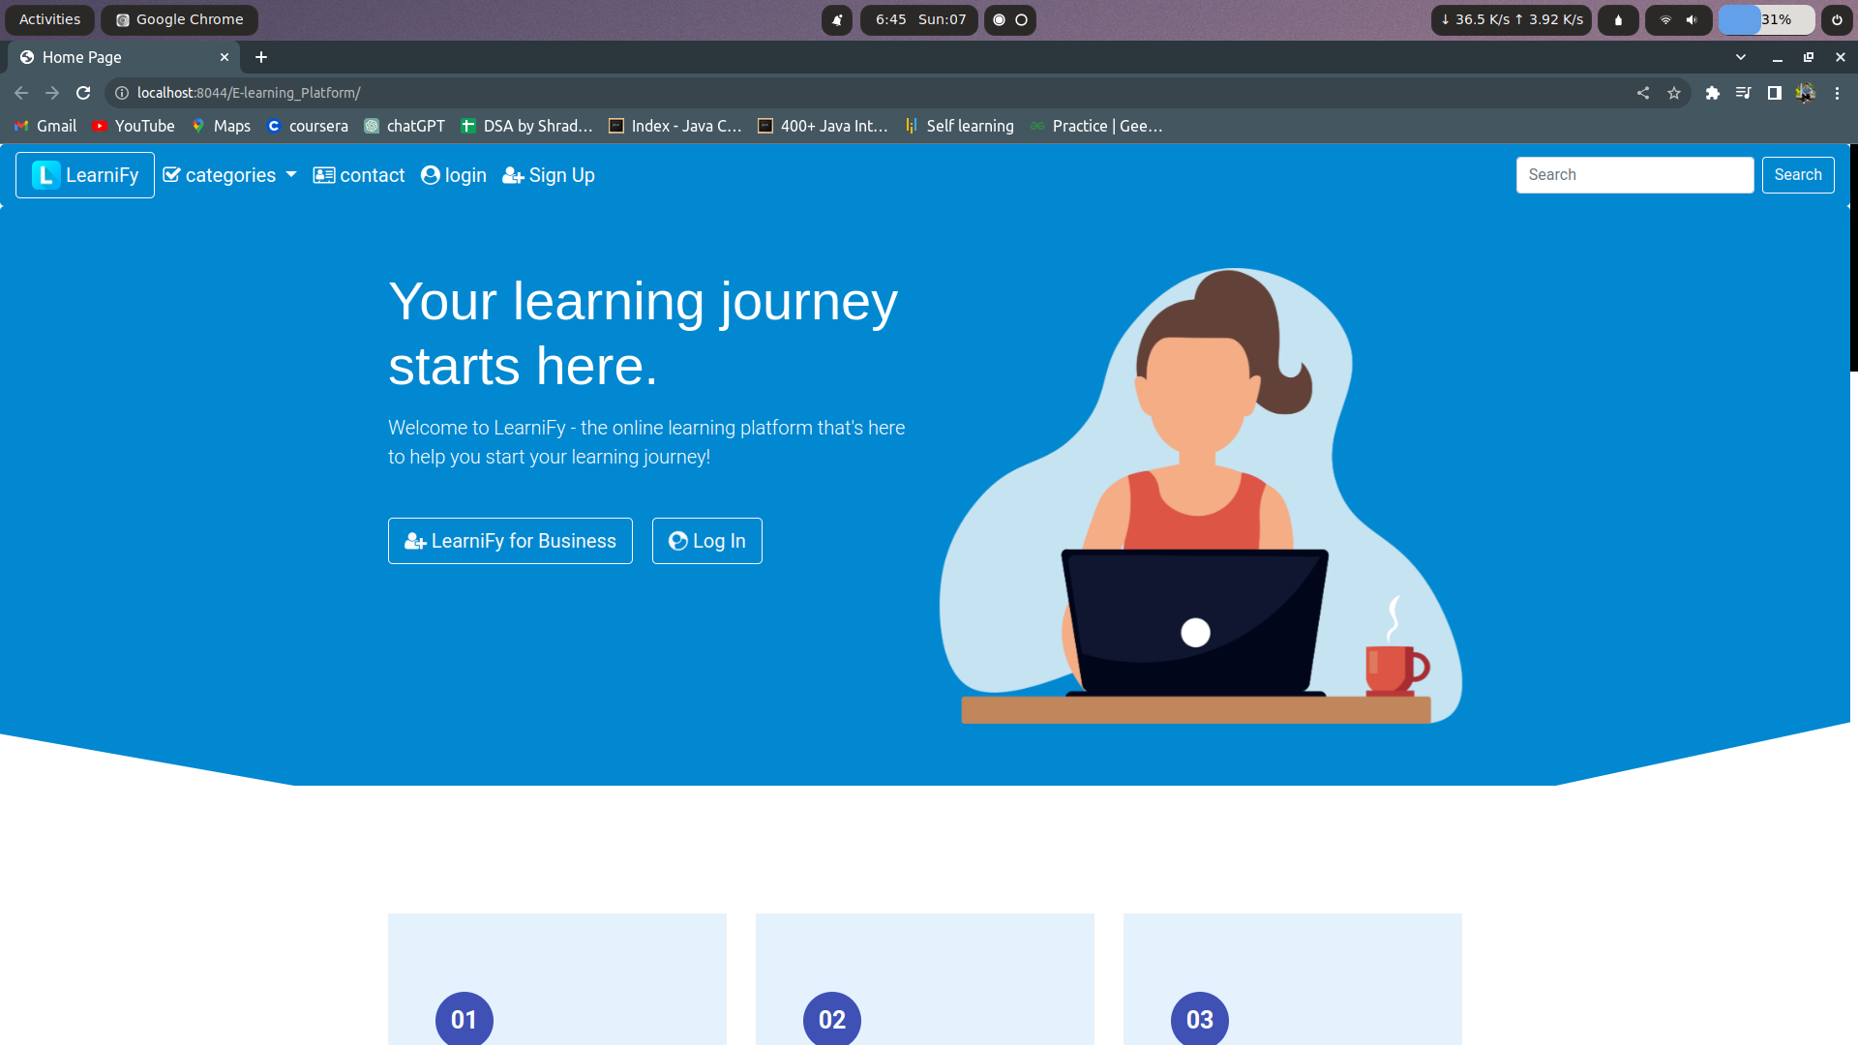

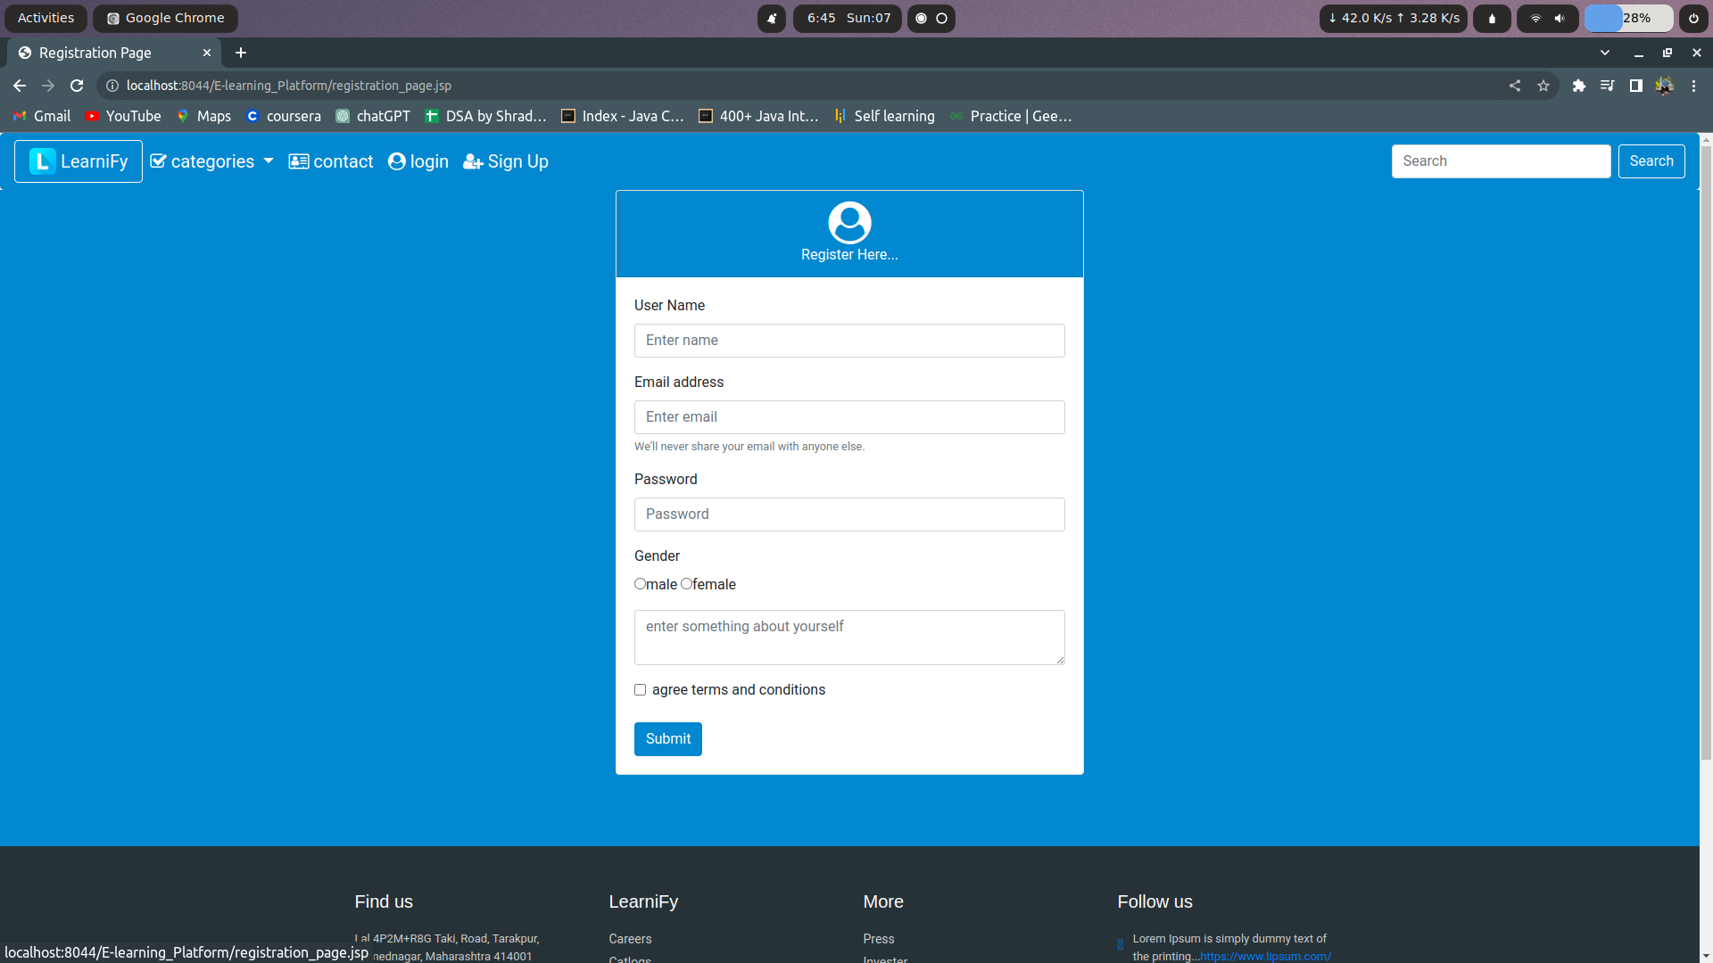

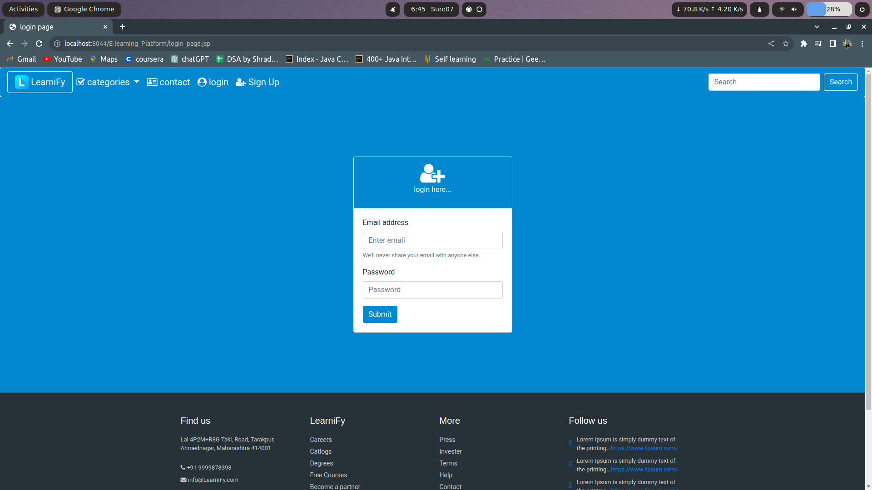

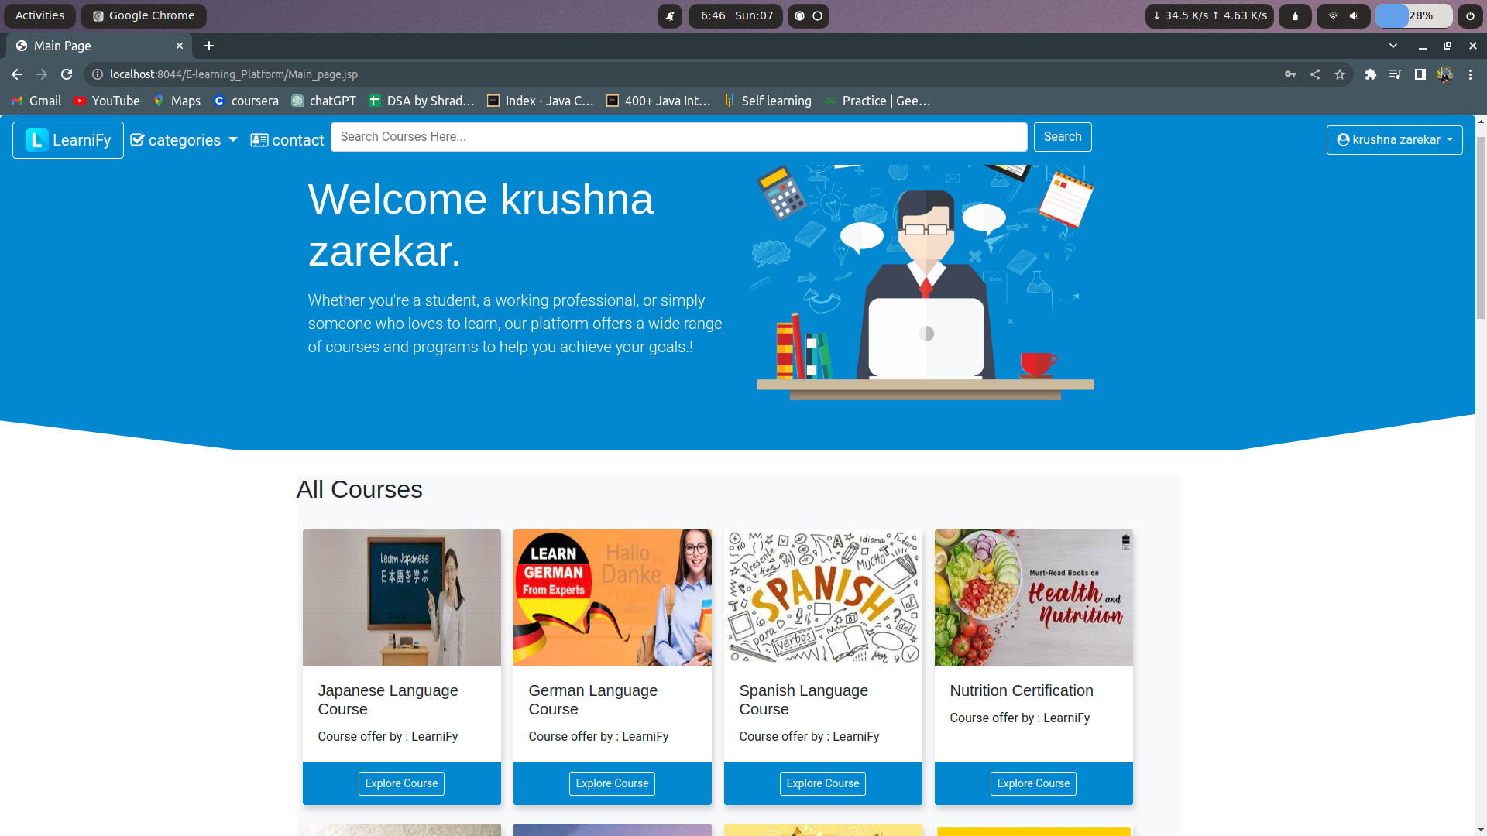

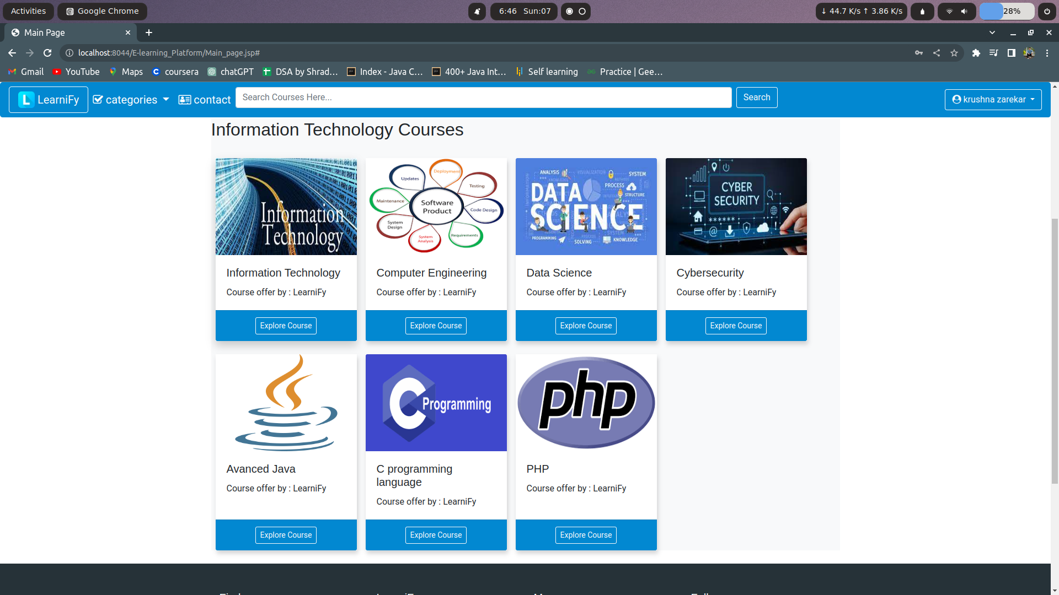

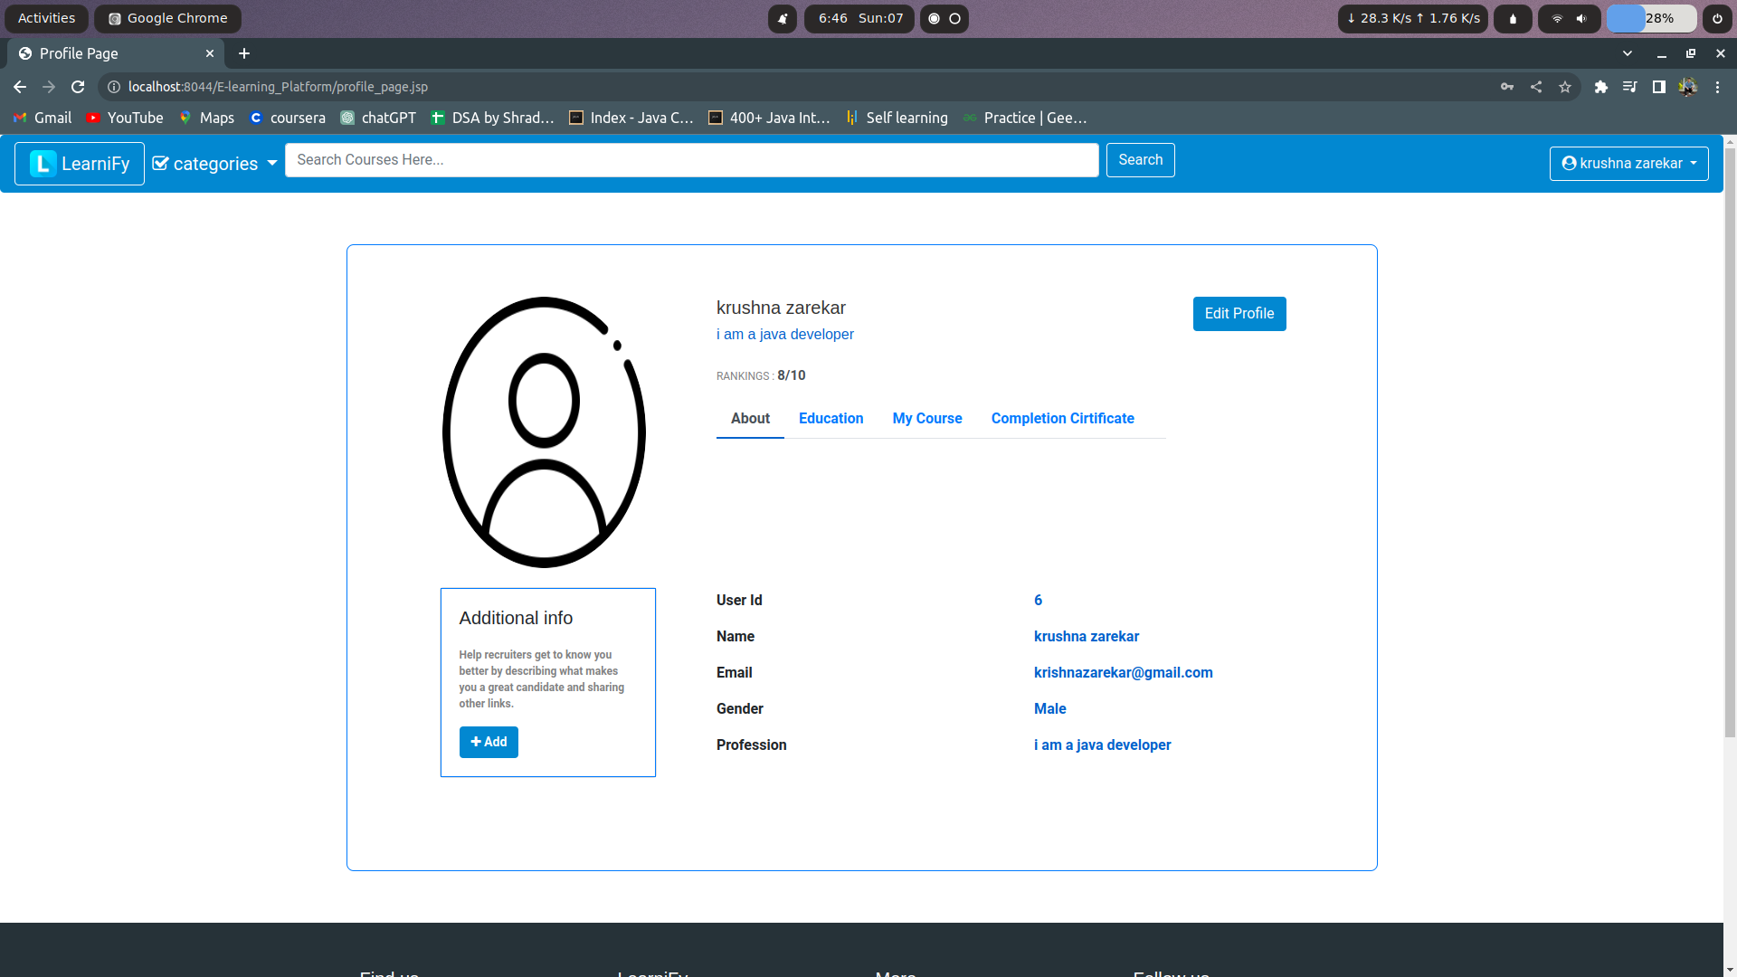

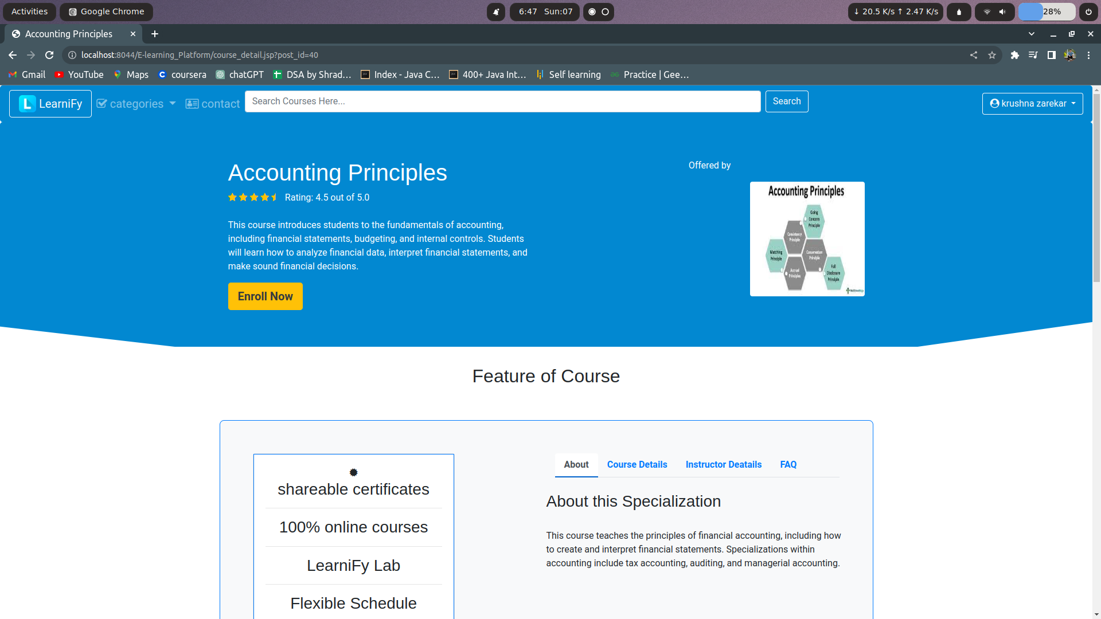

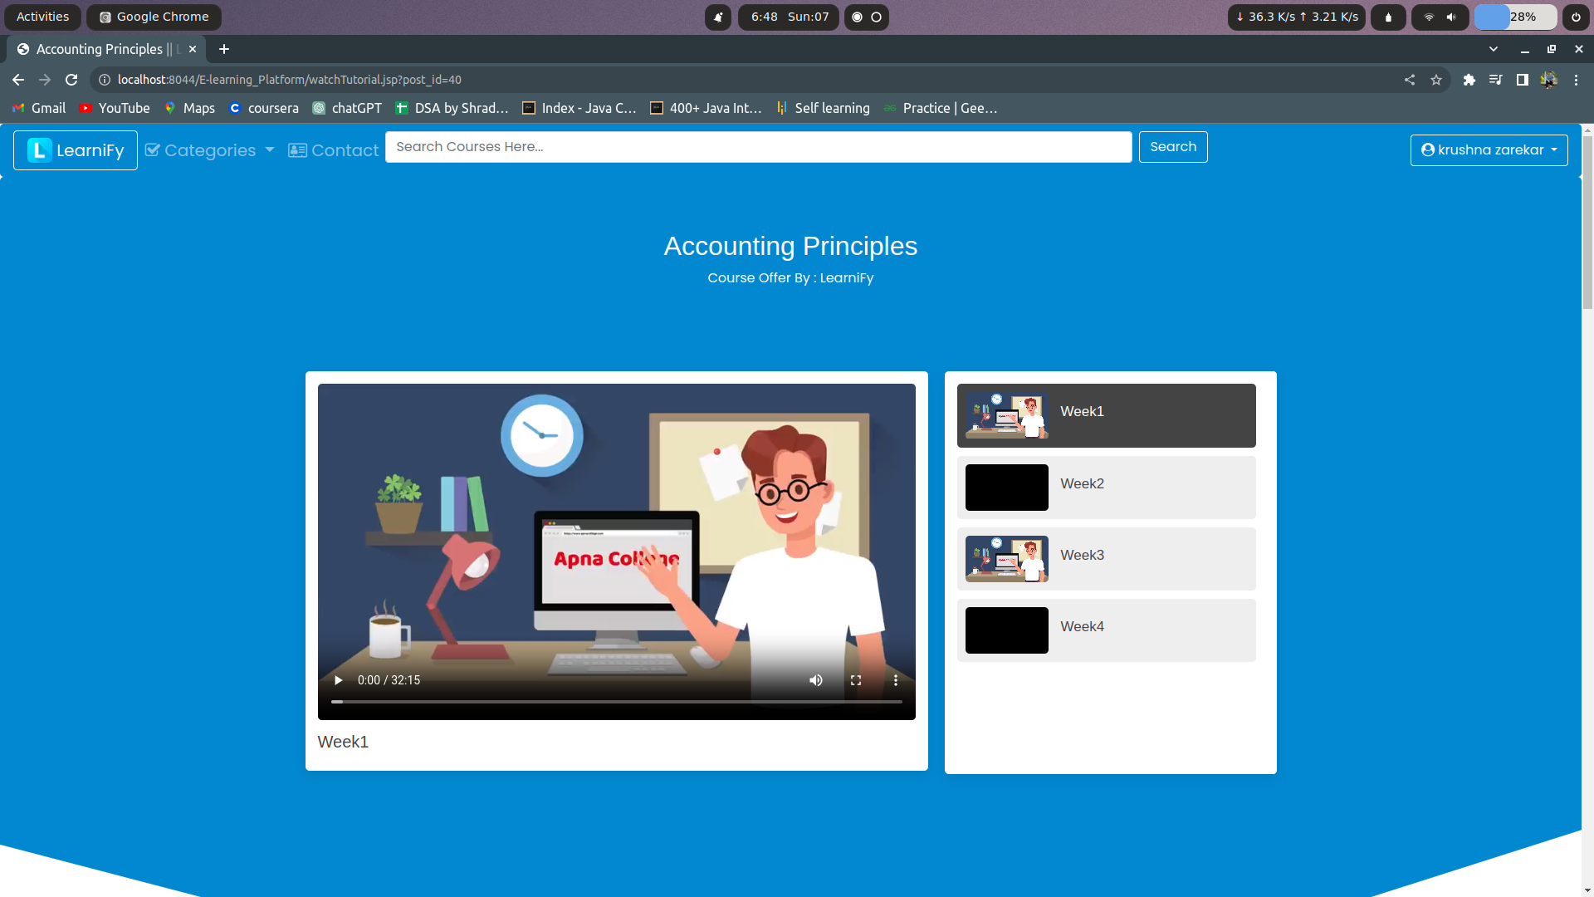

To Business :

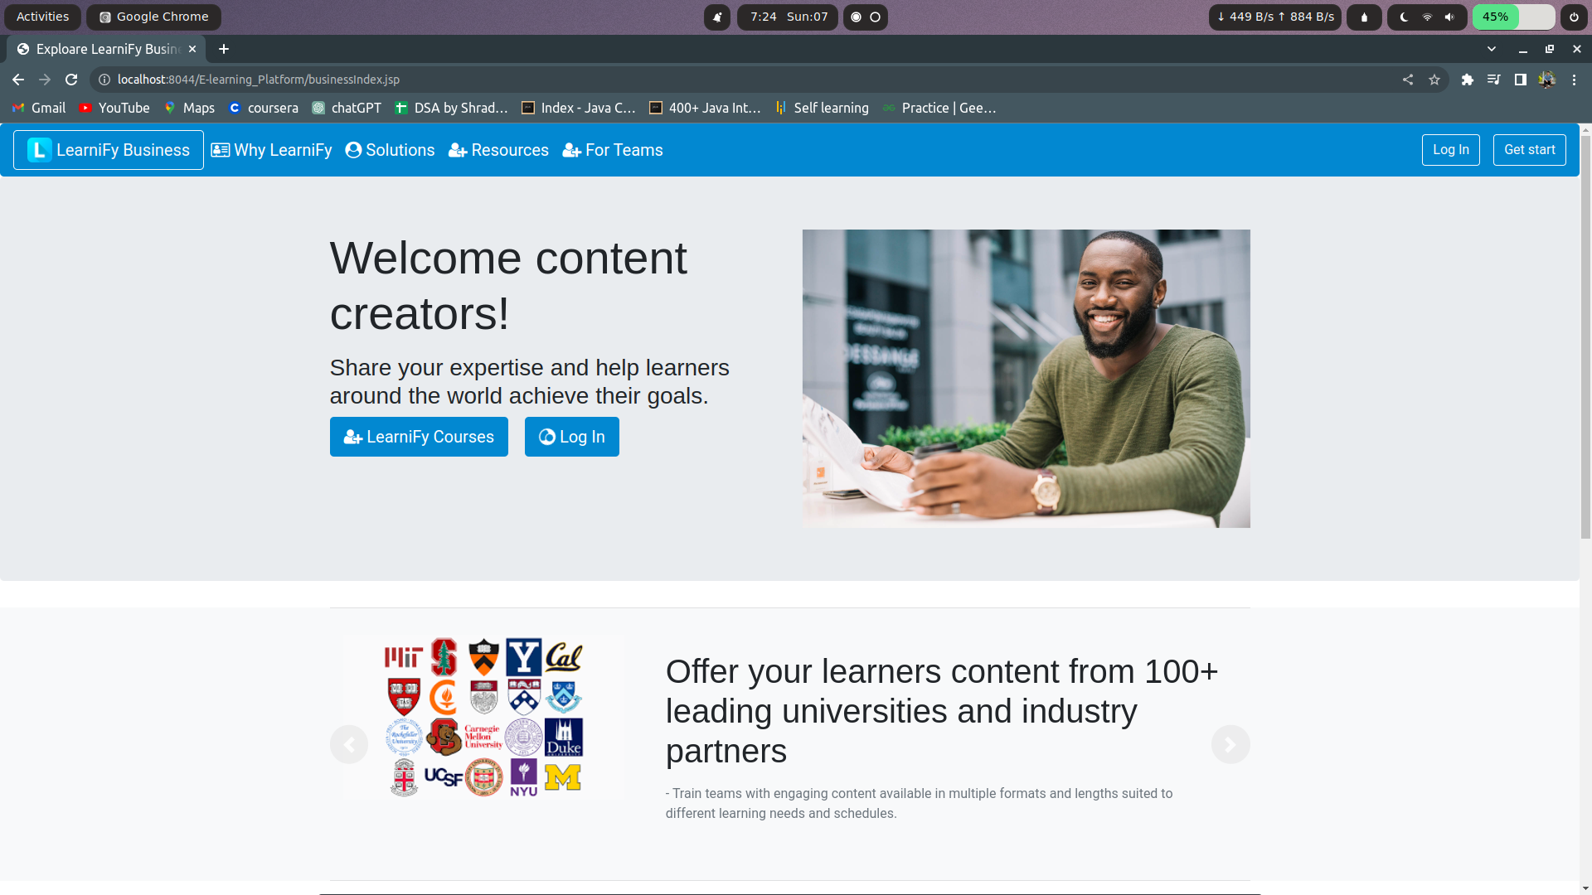

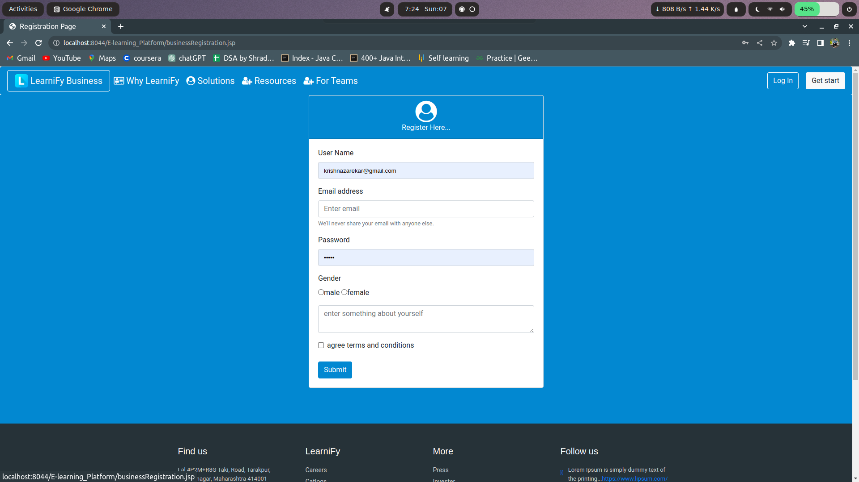



**7. DATABASE**

Tables :

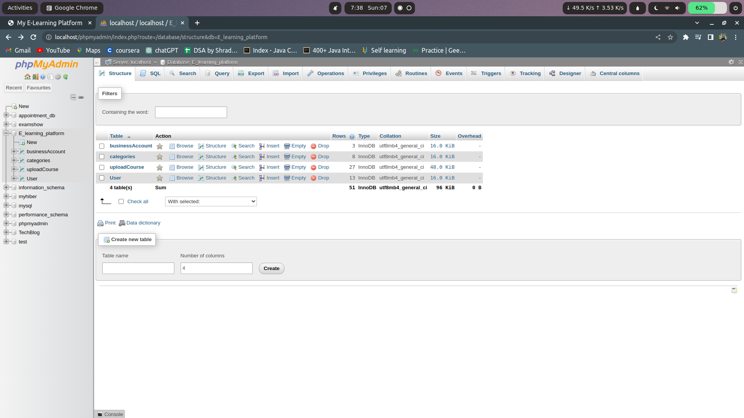

Business Account table

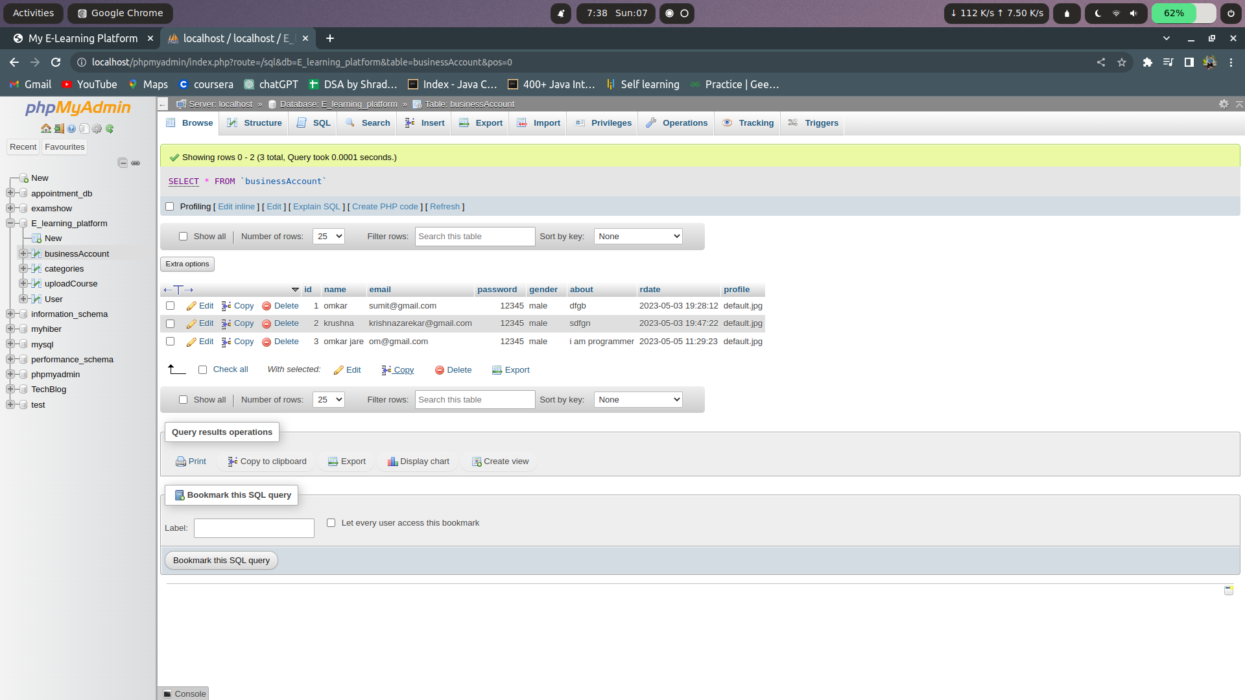

Categories table :

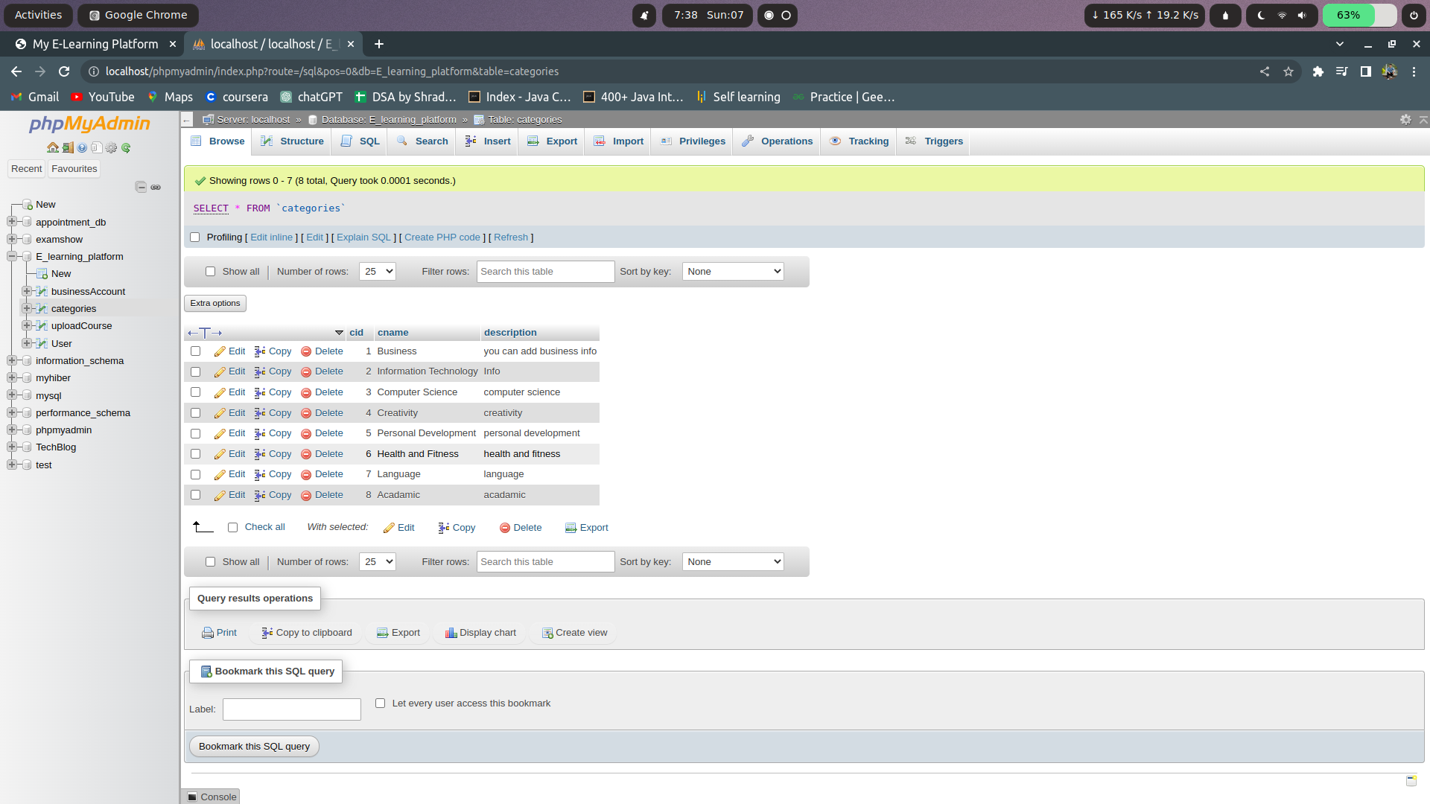

UploadCourses table :

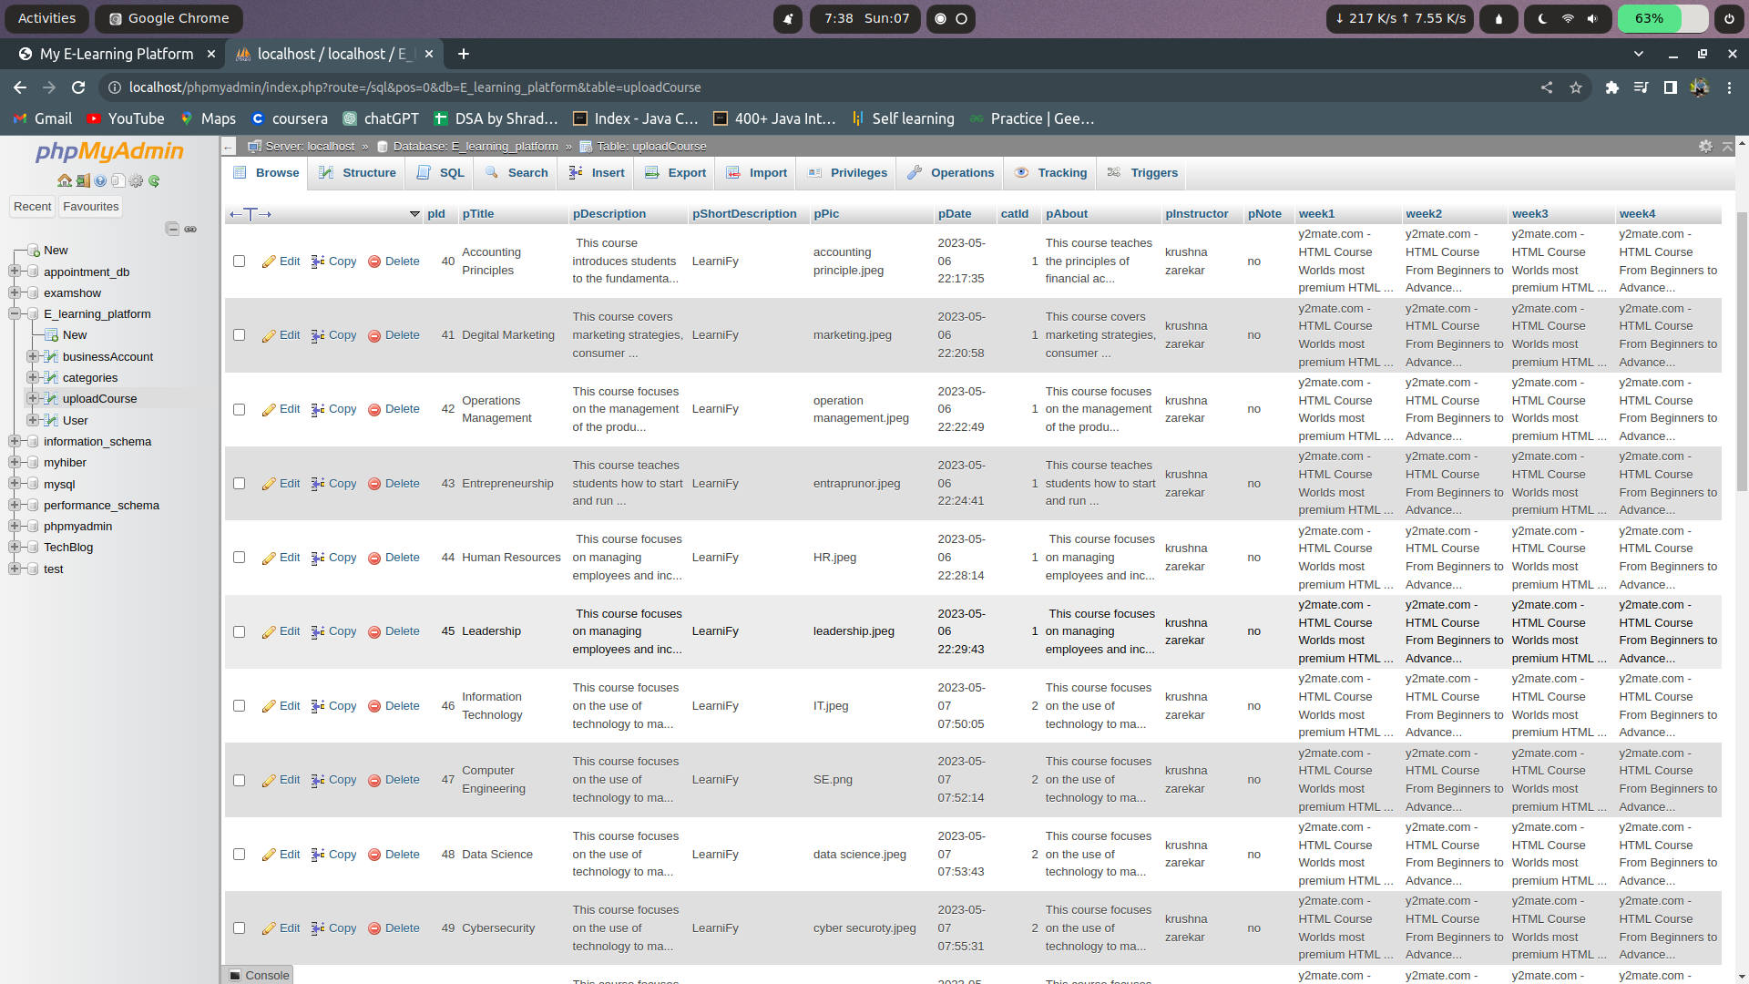

User table :

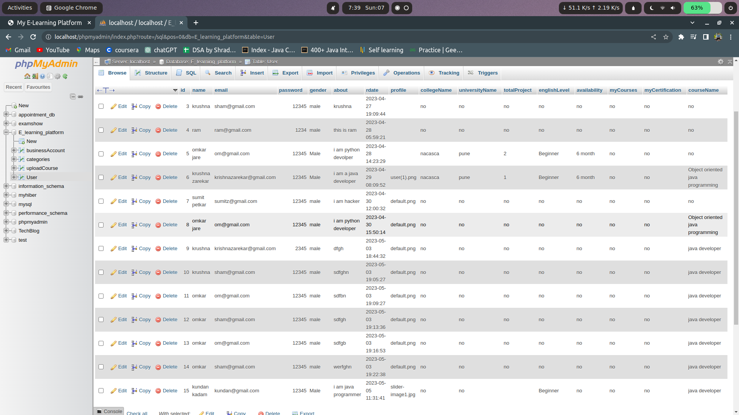

**8. FUTURE ENHANCEMENT**

1. Personalization: Tailoring the learning experience to each individual user's needs and interests can increase the effectiveness of the platform. This could involve recommending courses based on past behavior, allowing users to set their own goals, and providing personalized feedback.
2. Interactive Content: Incorporating interactive elements such as quizzes, simulations, and virtual reality experiences can make the learning process more engaging and immersive.
3. Mobile Compatibility: Ensuring that the platform is mobile-friendly will allow learners to access the content on the go and improve accessibility.
4. Social Learning: Incorporating social features such as discussion forums and group projects can foster a sense of community and collaboration among learners.
5. Multiple Learning Formats: Offering a variety of learning formats such as videos, podcasts, and ebooks can cater to different learning styles and preferences.

**9. CONCLUSION**

LearniFy is an innovative e-learning platform that provides learners with a flexible, accessible, and personalized approach to education. The platform's robust technical infrastructure, diverse course offerings, interactive learning materials, and user-friendly interface make it a powerful tool for acquiring new knowledge and skills. Additionally, its scalability, adaptability, and cost-effectiveness make it a viable and sustainable alternative to traditional education models.

LearniFy's operational and economic feasibility, as well as its hardware and software requirements, are crucial for ensuring the platform's reliability, scalability, and functionality. The platform's success depends on its ability to continuously evolve and adapt to the changing needs of learners and organizations, while maintaining its commitment to delivering high-quality education to all. Overall, LearniFy has the potential to transform the future of education, making learning more accessible, engaging, and effective for everyone.

**10. LIMITATION OF THE SYSTEM**

There are some limitation of the system :

1. LearniFy's effectiveness may be limited for certain types of hands-on or experiential learning that require physical presence.

2. Access to high-speed internet and reliable computer hardware may be a limitation for some learners in remote or underprivileged areas.

3. LearniFy may face challenges in establishing credibility and recognition in the educational industry as a relatively new e-learning platform.

**11**. **BIBLIOGRAPHY AND REFERENCES**

[WWW.W3SCHOOL.COM](http://www.w3school.com)

[WWW.CHAT.OPENAI.COM](http://www.chat.openai.com)

[WWW.BOOTSTRAP.COM](http://www.bootstrap.com)